The Magic Word
RULES: USPSA Handgun Competition Rules, Latest Edition COURSE DESIGNER: Kirt McKenna
START POSITION: Standing inside of the shooting area, feet touching X’s with wrists below belt.
Handgun is loaded and holstered.
PCC START: Same as handgun with stock on belt pointed down range.
STAGE PROCEDURE  On start signal engage targets as they become visible, from within the shooting area. | SCORING  SCORING: Comstock, 20 rounds, 100 points  TARGETS: 9 USPSA, 2 mini-poppers  SCORED HITS: 2 Best per USPSA  START-STOP: Audible - Last shot  PENALTIES: Per current USPSA rulebook

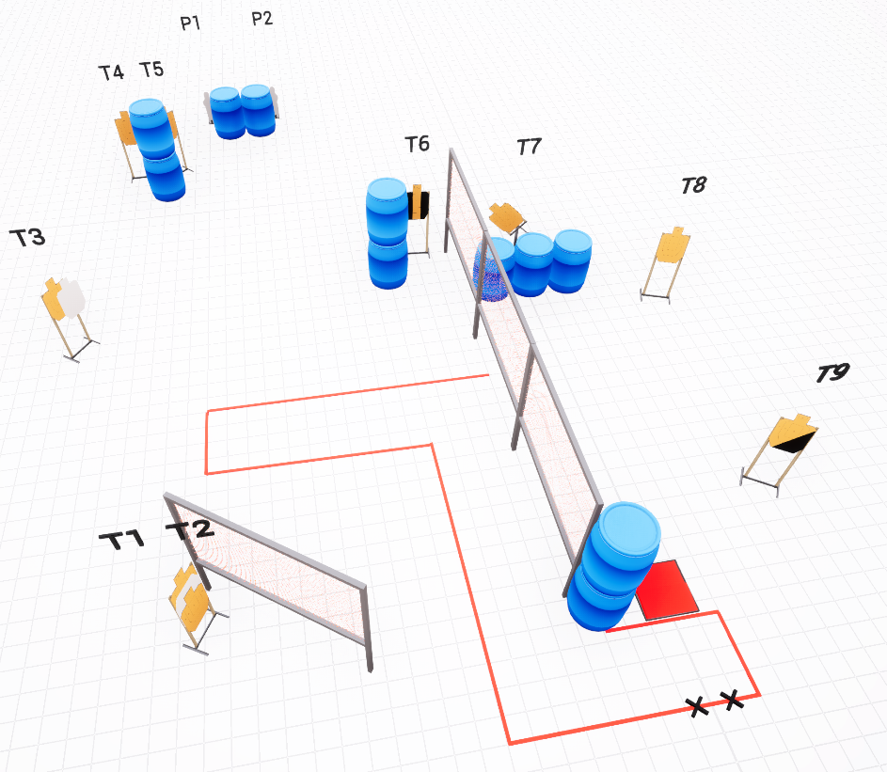

SETUP NOTES: Red Box is a Stomp Pad activator for T7 swinger. T4 & T5 have hard cover on barrel side. |  | RO NOTES:

